From: Cynthia Goldstein

To: Senior Finance Manager

Subject: Porter’s Five Force Model

Dear SFM,

As promised I have attached below the Porter’s Five Force model so that you can have a better understanding.

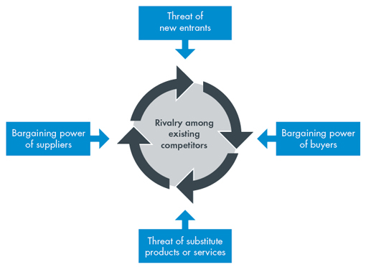

Please contact me if you need any further information.

Regards,

Cynthia